**Analytics in Microsoft Intelligent Data Platform (MIDP) DREAM Demo Script**

For demo feedback and other questions, please email [dreamdemos@microsoft.com](https://partner.microsoft.com/en-us/asset/collection/industry-dream-demos-and-dream-demo-in-a-box#/)  
For demo environment issues, please email [dreamdemossupport@spektrasystems.com](https://spektrasystems.com/)

DREAM demos for Microsoft sellers at [https://aka.ms/dreamdemos](https://nam06.safelinks.protection.outlook.com/?url=https%3A%2F%2Faka.ms%2Fdreamdemos&data=04%7C01%7Cv-edamore%40microsoft.com%7Ccd0046dd84d043ff525008da030b4d1d%7C72f988bf86f141af91ab2d7cd011db47%7C1%7C0%7C637825644529938336%7CUnknown%7CTWFpbGZsb3d8eyJWIjoiMC4wLjAwMDAiLCJQIjoiV2luMzIiLCJBTiI6Ik1haWwiLCJXVCI6Mn0%3D%7C3000&sdata=06GJRu3LRUViGr1bQHS9KbTurdKj71R4j0Cuxwmjuvk%3D&reserved=0).

DREAM Demos and DDiB assets for partners in **MPN Portal** at [https://aka.ms/dreamdemosforpartners](https://nam06.safelinks.protection.outlook.com/?url=https%3A%2F%2Faka.ms%2Fdreamdemosforpartners&data=04%7C01%7Cv-edamore%40microsoft.com%7Ccd0046dd84d043ff525008da030b4d1d%7C72f988bf86f141af91ab2d7cd011db47%7C1%7C0%7C637825644529938336%7CUnknown%7CTWFpbGZsb3d8eyJWIjoiMC4wLjAwMDAiLCJQIjoiV2luMzIiLCJBTiI6Ik1haWwiLCJXVCI6Mn0%3D%7C3000&sdata=S8vme76wWCqIqxKFL7W3xgDIO4nm5acND9Qn3ruzId0%3D&reserved=0).

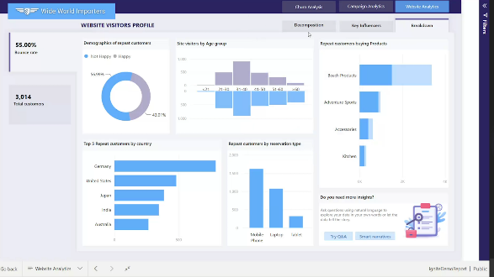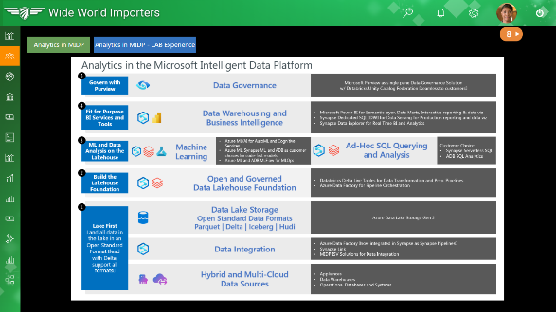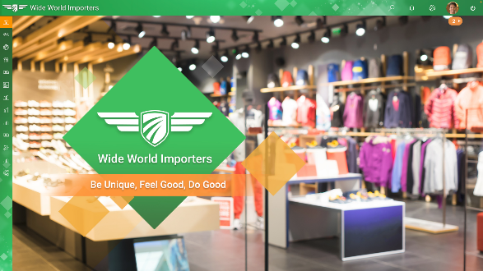

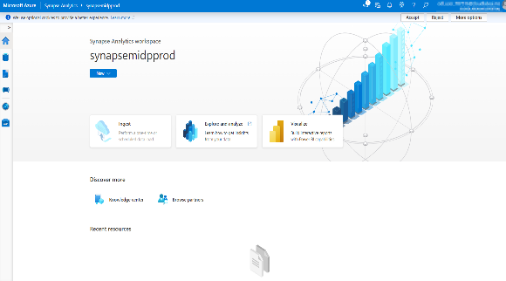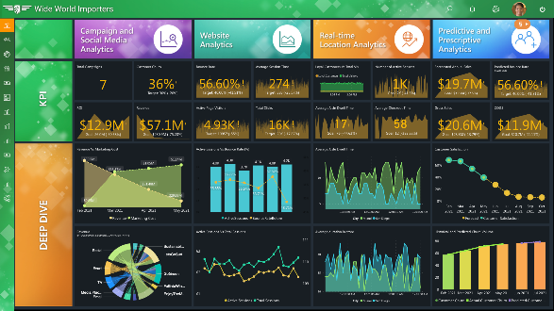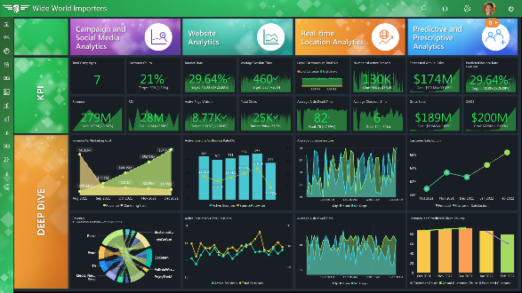

Table of Contents

1 Setting the Scene 4

1.1 Demo Overview 4

1.1.1 Implementing a Lake First Data Foundation for Analytics 4

1.1.2 Implementing an Open and Governed Data Lakehouse 4

1.1.3 Machine Learning and Data Analysis in the Microsoft Intelligent Data Platform 5

1.1.4 Business Intelligence in the Microsoft Intelligent Data Platform 5

1.1.5 Data Governance in the Microsoft Intelligent Data Platform 5

1.1.6 Azure Data Lake Storage Gen2 6

1.1.7 Azure Machine Learning 6

1.1.8 Cosmos DB with Azure Synapse Link 6

1.1.9 Power BI 6

2 Demo Scenario 7

2.1 Demo Architecture 8

2.2 Demo Introduction 9

2.3 CEO Dashboard 9

3 Demo 17

3.1 Data ingestion from a spectrum of analytical and operational data sources into the Lakehouse 17

3.1.1 Explore a Streaming data and analytics pipeline using ADX for a near real time analytics scenario 18

3.1.2 Explore a few Synapse pipelines that ingest raw data from analytical data sources to the bronze layer of the Data lake 26

3.1.3 Explore a few Synapse pipelines that ingest raw data from operational data sources to the Bronze layer of the Data Lake 30

3.1.4. Near real-time data availability with Azure synapse link for Azure Cosmos DB 32

3.2 Explore offline data and analytics pipeline using open Delta format and Azure Databricks Delta Live Tables. Stitch streaming and non-streaming data landed earlier, to create a combined data product to build a simple Lakehouse. 33

3.2.1 Set up Azure Databricks environment 34

3.2.2 Review sentiment analysis model training 37

3.2.3 Review Delta Live Table pipeline 38

3.3 Explore Machine Learning and Business Intelligence scenarios on the Lakehouse 43

3.3.1 Review MLOps pipeline using the Azure Databricks managed MLflow and Operationalized as an ML service in Azure ML 43

3.3.2 Leverage Power BI to derive actionable insights from data in the Lakehouse 53

3.3.3 Explore SQL Analytics with Azure Synapse Serverless 68

3.3.4 Explore SQL Analytics with Azure Databricks 72

3.4 Data Governance with Microsoft Purview 78

4 CEO Dashboard & Finale 94

**DISCLAIMER** 96

# Setting the Scene

**Important!**

Before starting the demo, please watch [this](https://msit.microsoftstream.com/video/9b30a1ff-0400-85a8-0d14-f1eb7c821e56?channelId=faa089ba-c8dd-4f4b-8b8c-091f0ccacfc1) [**Analytics in Microsoft Intelligent Data Platform (MIDP) DREAM demo Video**](https://msit.microsoftstream.com/video/1edb0840-98dc-ba75-6577-f1eda74357cf) for important background information.

## Demo Overview

This demo showcases Analytics in the **Microsoft Intelligent Data Platform**. The Analytics solution pattern is a cost-effective, performance-optimized, and cloud-native architecture that helps our customers unify their data estate to accelerate data value creation.

The example in this demo showcases a traditional midsized retailer with an online store and many brick-and-mortar stores worldwide. We will see how they built a solution to help management make strategic, data-driven decisions and improve their top and bottom lines.

The solution layers depicted here are as follows:

### Implementing a Lake First Data Foundation for Analytics

Microsoft’s overall approach is based on an open and governed Data Lakehouse foundation for analytics. The open and governed Data Lakehouse foundation is a cost-effective and performance-optimized fabric for business intelligence, machine learning, and AI workloads at any scale. It is the foundation for migrating and modernizing existing analytics solutions, whether this be data appliances or traditional data warehouses. Finally, Data Lakehouse is foundational for integrating data across a broad spectrum of emerging operational databases and systems, including modern analytics applications.

### Implementing an Open and Governed Data Lakehouse

With raw data landed in the data lake, it’s time to transform and prepare the data for analytics applications. We believe the best solution for data transformation and preparation is to anchor to an open and governed data Lakehouse. This provides a unified approach to serve the full spectrum of BI, ML, and AI applications. In the past, data lakes were used to serve data science applications, data warehouses, and data marts for BI applications. They relied on complex ETL pipelines to move data between and across the fabrics. Now with the data Lakehouse foundation, we have a unified foundation to serve the most demanding BI, ML, and AI applications while optimizing performance and cost.

### Machine Learning and Data Analysis in the Microsoft Intelligent Data Platform

Machine Learning: Data scientists can bring their preferred compute frameworks, languages, runtimes, and tools to the data Lakehouse to access data prepared for ML applications. In addition, they can further refine and enhance the data through feature engineering and additional statistical techniques. In most environments, experiments are performed iteratively to produce machine learning models which provide the desired business outcomes.

Data Analysis: Ad-hoc and interactive data analysis using notebooks is a top line workload and experience for data analysts. While data analysts can also use the Spark modalities generally used by data scientists, data analysts typically prefer SQL modalities. Until recently, there was no clean solution to enable ad-hoc and interactive SQL data analysis directly on data in a data lake. With recent advances, we have solutions to address this need with the following customer options in the Microsoft Intelligent Data Platform:

* Synapse Serverless SQL notebooks
* Azure Databricks SQL Analytics notebooks

### Business Intelligence in the Microsoft Intelligent Data Platform

The Microsoft Intelligent Data Platform offers best-in-class integrated solutions to responsibly democratize business intelligence with self-serve tools and experiences for data analysts and data citizens.

### Data Governance in the Microsoft Intelligent Data Platform

Microsoft Purview is the single-pane data governance solution in the Microsoft Intelligent Data Platform. It provides a means to effectively scan and manage customers’ analytics estates in Microsoft Purview. Our customers will also see the Databricks Unity Catalog when using Azure Databricks. We seamlessly integrate Purview with the Databricks catalog and ‘metastore’ to enable a single pane governance solution and experience that spans the MIDP analytics estate across Azure Data Lake, Synapse, Azure Databricks, Power BI, and Azure Machine Learning. Microsoft Purview serves as a single-pane solution to address end-to-end data governance.

### Azure Data Lake Storage Gen2

A set of capabilities dedicated to Big Data Analytics, built on Azure Blob Storage. Data Lake Storage Gen2 enables hierarchical namespace to Blob storage.

### Azure Machine Learning

Empowers data scientists and developers with a wide range of productive experiences to build, train, and deploy machine learning models and foster team collaboration. Provides Robust MLOps capabilities that enable the creation and deployment of models at scale using automated and reproducible machine learning workflows. Automated machine learning may be used to rapidly create accurate models for classification, regression, and time-series forecasting. Model interpretability can be utilized to understand how the model was built.

### Cosmos DB with Azure Synapse Link

Using Azure Cosmos DB analytical store, a fully isolated column store, Azure Synapse Link enables no Extract-Transform-Load (ETL) analytics in Azure Synapse Analytics against your operational data at scale. A cloud-native hybrid transactional and analytical processing (HTAP) capability that enables you to run near real-time analytics over operational data in Azure Cosmos DB. It creates a tight seamless integration between Azure Cosmos DB and Azure Synapse Analytics. It helps break down the barrier that has long existed between the OLTP and OLAP systems by enabling near real-time analytics over operational data. Single-digit millisecond response times (near real-time), Analytics of operational data in Azure Cosmos DB, with no ETL and no performance impact on transactional workloads.

### Power BI

Power BI is a collection of software services, apps, and connectors that work together to turn your unrelated sources of data into coherent, visually immersive, and interactive insights. It helps lead to actionable items by digging deeper into data. It allows the creation of mobile-optimized reports (published to the cloud or on-premises), creating a Power BI desktop using embedded reports into existing websites or apps.

# Demo Scenario

This demo explores an end-to-end implementation of an open standard data Lakehouse. You can explore raw data ingestion from disparate data sources that transform data by using Delta Live Tables in Azure Databricks. This ingestion creates data products that can be further leveraged by data science, machine learning, and business intelligence applications. This demo will demonstrate the capability of Lakehouse to serve as a single platform for managing and supporting data and analytics needs. You will work through an example of a real-world implementation for the fictitious Wide World Importers Enterprise.

Wide World Importers is a brick-and-mortar retailer with hundreds of stores worldwide and a fast-growing online store. It sells a wide variety of consumer merchandise, including sunglasses, sports shoes, watches, wallets, books, and various beach products.

The demo scenario starts on May 30th, 2022. The company's new CEO, April, recently noticed a few negative trends in their KPIs, including:

* High customer churn
* Declining sales revenue
* High bounce rate on their website
* Poor customer experience

In a purely reactive mode, as soon as the company saw these adverse KPI trends, they launched some traditional campaigns. On September 5th, Labor Day, they received the results of those campaigns. The campaigns had failed. So, April talked with Rupesh, the Chief Data Officer (CDO), about these adverse KPI trends and recommended a data-driven approach.

In this activity, you will see from the eyes of a data engineer, how Rupesh improves the KPIs using the following requirements:

* Leverage data from the past, present, and future (Volume).
* Enable quick turnaround time (Velocity).
* Support open standards data format (Variety).

## Demo Architecture

Below is a visual representation of the activities we will perform in this demo.

## Demo Introduction

In this demo, we meet April, the new CEO of a fictitious company called Wide World Importers.

April believes in the potential of data. In the past, she has assessed the best ways to archive structured data for specific business intelligence purposes and reporting. Her data management techniques have enabled her previous organizations to make quicker and more efficient data-driven decisions. When April joins Wide World Importers as the new CEO, she discovers that Wide World Importers has data coming in from disparate sources. However, they are still using data warehouses which are limited to processing structured data. When data consumers such as the Business Analysts or data scientists request more data, they get put into a queue. It’s time for Wide World Importers to simplify their data management techniques to not only make the process cost-efficient, but also to deliver faster and higher quality services to their customers.

Let’s step into her shoes and see how she and her team implements an open standard data Lakehouse to bring their data together in one place and derive their insights from this data after processing them using AI and ML.

Let’s get started.

## CEO Dashboard

|  |  |  |
| --- | --- | --- |
| **Narrative** | **Steps** | **Screenshot** |
| Let’s get started by navigating to the **Wide World Importers** Web application. | 1. Close all browsers or any web application in use before starting the following steps. |  |
| For a seamless demo experience, please open a new browser in **InPrivate** mode. | 1. **! Open** a new browser window in InPrivate Mode. | Window showing browser in InPrivate mode. |
|  | 1. **Open** the On-Demand lab. 2. **Select** the “Environment Details” tab. 3. **Click** on “Resources and URLs”. 4. **Copy** the Web App URL. 5. **Paste** the URL in your browser and open the web app. | Cloudlabs |
| Let’s log in as April, the group CEO of Wide World Importers. | 1. **Log into** the Wide World Importers application. Use the prefilled username and password.   **Username:** [April@WideWorldImporters.com](mailto:April@WideWorldImporters.com)  **Password:** M1cr050ft#1! |  |
| **Legal Notice**  First, we will start the demo with the **CELA**-approved legal notice. You will see similar notices in different places throughout the demo, including the machine learning notebooks and SQL code. | 1. **Click** on Step 1**.**   ***Note:*** *It is important for you, as a seller or partner, to show this screen to the customers every time you do this demo.* | Screenshot from Webapp |
| **Wide World Importers**  Wide World Importers is a medium-sized global retail business with stores in many locations across the world. They also have an online store. Product lines offered include apparel, furniture, wine, pharmaceuticals, skincare, home goods, beach products, and many more. | 1. **Click** on Step 2. | Wide World Importers Page |
| April is new to the organization, and she is happy to see that they have stores all over the world.  She can hover over various cities and see the five major KPIs that are most important to her including:   * Revenue * Churn Rate * Bounce Rate * Available Inventory * Customer Experience. | 1. **Hover** over New York City. 2. **Click** on Step 3. | World Map |
| Right now, she is at the headquarters of Wide World Importers in New York city.  And she has a dream… | 1. **Click** on Step 4. | New York City |
| She would like her team to create a dashboard like this one for data-driven decision making…  She wants to see the group KPIs that matter the most across all pillars.  She also wants her team:   * to obtain insights from structured and unstructured data from various sources combined in one dashboard. * to leverage near real-time data * to perform predictive and prescriptive analytics and see the projected future trends in KPIs.   In a way, based on the past, better decisions for the present, and based on the present, better decisions for the future.  This demo starts on May 30th, 2022. Their five most important KPIs were not doing so well.   * Revenue – decreasing. * Marketing cost – increasing. * Customer churn – very high * Bounce rate – very high for the website. * Available Inventory – Demand is high, but it seems the available inventory is far less than the demand.   She wants to change all this in the next 6 months. She plans to present this at the Wide World Importers Annual Conference, in New York, on December 10th, 2022. | 1. **Show** KPIs “Revenue vs. Marketing Cost,” “Active sessions vs. Total sessions,” “Active sessions vs. Bounce rate,” “Market Sentiment,” and “Historical and predicted churn volume” and discuss trends. 2. **Click** on Step 5. | CEO Dashboard |
| So, she talks to the CDO and CIO, who are part of her leadership team shown here. | 1. **Click** on Step 6. | Org chart |
| She dreams about the moment at the Retail Conference on December 10th, 2022. | 1. **Click** on the Analytics MIDP Webapp Screenshot button in the center of the screen to play the teaser video. | Dream Video |
| She imagines showing a green dashboard at the event with amazing transformations and receiving a huge round of applause.  However, the reality is different. Currently, they have an orange dashboard with all the important KPIs underperforming.  She decides to spring into action and meets with her team. Let’s see what her team does… | 1. **Pause** at the orange KPI dashboard. 2. **Finish** the remaining video. 3. **Click** arrow 7. | Orange KPI Dashboard |
| First, let's look at the North America Metrics Power BI report.  According to this chart, New York has the highest Customer Churn Rate at 20%, shown in dark red. Now, let’s drill into more details regarding that high churn. | 1. **Click** on Step 8. | North America Metrics |
| Here is the detailed Revenue & Customer Churn report. It confirms that customer churn is extremely high in New York City.  So, she selects “New York” to better understand who is churning and which products are most affected by the churn.  She can see products like running shoes, gaming consoles, and dining furniture have the most Customer Churn.  She can also see the Customer Churn by Generation. It’s obvious that millennials are leaving them the most. | 1. **Select** New York in Decomp Tree. 2. **Show** “Customer Churn by Product”. 3. **Show** Customer Churn by Generation. 4. **Click** arrow 9. | Revenue and Customer Churn |
| To accomplish this transformation needed to attract millennial customers and improve the KPIs, she talks to the Chief Data Officer (CDO).  The CDO has a team of data engineers, data scientists, and data analysts who implement an integrated, open, and governed Data Lakehouse foundation based on the Microsoft Analytics Solution pattern part of MIDP. | 1. **Click** on Step 10. | Architecture Diagram |
| Here are the steps that we showcase in this demo.  Let’s look at the back-end implementation by the data engineer, data scientist, and data analyst who worked together to prepare for the Black Friday sale on November 25th, 2022. | 1. **Click** on Step A. | Architecture Diagram |

# Demo

## Data ingestion from a spectrum of analytical and operational data sources into the Lakehouse

As a data engineer at Wide World Importers, you will start by landing data from a variety of sources into the Lakehouse. This data will be further cleansed, processed, and transformed by using Azure Databricks and Delta Live Tables. This is a preparation step for downstream consumption of the data by the data scientists and business intelligence analysts. Data sources include data related to its customers, products, marketing campaigns, social media, and sales transactions. This data is often generated in raw files format such as CSV, JSON, unstructured files, and even images. A lot of the existing data is historical as well.

To boost customer satisfaction, gain a competitive advantage, and ultimately drive revenue growth, Wide World Importers wants to analyze its data to obtain meaningful insights related to their customers, marketing campaigns, and sales forecasts. However, their immediate challenge is to generate and use near real-time streaming data. So, they installed IoT devices in their stores to analyze customer shopping patterns and thermostat readings.

In this activity, you will explore the data ingestion scenario from analytical data sources to the bronze layer using Synapse pipelines.

### Explore a few Synapse pipelines that ingest raw data from analytical data sources to the bronze layer of the Data lake

|  |  |  |
| --- | --- | --- |
| **Narrative** | **Steps** | **Screenshot** |
| The first step in data modernization journey for Wide World Importers is to bring their data from disparate data sources and land it to the bronze layer of the data lake.  In this task you will ingest campaigns data from Snowflake and customer churn data from Teradata into the data lake. | 1. In Synapse Studio, from the left navigation, **select** the **Integrate** hub icon (the fourth from the top). 2. In the **Integrate** hub, expand **Pipelines**. 3. **Expand** the 1 Enterprise Data Sources in The Lake folder. 4. **Expand** the Landing Analytical Store Data folder. 5. **Select** the Campaigns Data from Snowflake pipeline.   **Note:** If required, collapse the panes on the left using the << icon at the top right of each pane. | Synapse Studio, |
| The Campaigns Data from Snowflake pipeline has two activities. The first one runs a lookup of data at the source Snowflake connection. The next activity brings that data into the bronze layer in ADLS Gen2. | 1. In the pipeline designer, select Lookup activity. 2. In the pane below, select the **Settings** tab. 3. In the **Source dataset** dropdown list, notice that **SnowflakeTable** is selected. | Analytics MIDP Backend Screenshot |
|  | 1. In the pipeline designer, select **Copy data** activity. 2. In the pane below, **select** the **Sink**tab. 3. In the **Sink dataset** dropdown list, notice that **SnowflakeCampaignsData** is selected. | Analytics MIDP Backend Screenshot |
| Similarly, the next pipeline is designed to ingest customer churn data from Teradata and Twitter data to the data lake. |  | ingest customer churn data from Teradata and Twitter data to the data lake. |

### Explore a few Synapse pipelines that ingest raw data from operational data sources to the Bronze layer of the Data Lake

|  |  |  |
| --- | --- | --- |
| **Narrative** | **Steps** | **Screenshot** |
| In this task, you will explore the design of a Synapse pipeline that is designed to ingest raw data coming from various operational sources into the data lake.  The **Store Transactions Data from SQL DB** pipeline has two activities. The first one runs a lookup of data at the source Azure SQL Database connection. The next activity brings that data into the bronze layer in ADLS Gen2. | 1. In Synapse Studio, at the left, select the **Integrate** hub icon (the fourth from the top). 2. In the **Integrate** hub, **expand** Pipelines. 3. **Expand** the 1 Enterprise Data Sources in The Lake folder. 4. **Expand** the Landing Operational Store Data folder. 5. **Select** the Store Transactions Data from SQL DB pipeline.   ***Note:****If required, collapse the panes on the left using the << icon at the top right of each pane.* | The Store Transactions Data from SQL DB |
| In the **Sink dataset** dropdown list, notice that **DestinationDataset** is selected to ensure it is ingested to the data lake. | 1. In the pipeline designer, **select** the Copy data activity. 2. In the pane below, **select** the **Sink** tab.   ***Note:****The image is for informational purposes only. The pipelines have been executed in advance for the demo.* | Analytics MIDP Backend Screenshot |
| Similarly, the next pipeline is designed to ingest Sales data from Oracle to the data lake.  Congratulations! From the perspective of a data engineer, we have now successfully ingested streaming near real time as well as historical data into data lake for Wide World importers. |  | Analytics MIDP Backend Screenshot |

### Near real-time data availability with Azure synapse link for Azure Cosmos DB

|  |  |  |
| --- | --- | --- |
| **Narrative** | **Steps** | **Screenshot** |
|  | 1. Switch back to the CloudLabs On Demand lab tab, then Under Environment Details, select **Resources and URLs**. 2. **Copy** Azure Cosmos DB URL. 3. **Paste** the URL in your active InPrivate Edge browser and navigate to that page. |  |
| They also have inventory management data about solar panels stored inside Azure Cosmos DB. | 1. **Navigate** to Data Explorer from the left pane. 2. **Open** the ‘Telemetry’ container. 3. **Open Inventory collection.** 4. **Select** Items. 5. **Select** one document**.** |  |
| They can query this data in near real time by enabling the power of Synapse Link for Cosmos DB.  They can query the data directly inside the Synapse workspace.  This enables them to get the latest inventory updates without having to wait for an ETL process to bring this data into the analytical store. | 1. **Navigate** back to Azure Synapse Analytics. 2. **Open** Develop hub. 3. **Expand** SQL scripts. 4. **Open** the “2 Available- Inventory” query under SQL Scripts. 5. **Select** Built-in connection. 6. **Run** the query. 7. **Show** last updated column. |  |

# CEO Dashboard & Finale

|  |  |  |
| --- | --- | --- |
| It’s now December 10th, 2022. The moment has arrived! Wide World Importers has had a great year.  Their agility towards implementing analytics in MIDP helped them discover the root cause of their high bounce rate. This discovery let them improvise their website with better user experience web apps and mobile apps and understand the demands of their target customers better. Such deep insights into their customers helped them strategize their campaigns well in advance and as a result, their Monday Cyber Sale Event was a hit.  Their marketing costs have been reduced. Customer churn has dropped, and revenue has increased. The engagement rate on social media is amazing and customer satisfaction is predicted to continue to rise.  With the help of Azure Data Explorer, near real-time social media analytics, and Azure Synapse Link, April and her team have made a big impact.  Looking at her dashboard, April can clearly see the impact of developing a strategy to not just use new tools and channels to engage with their customers, but also to bring the resulting data from those channels together into a single central location for internal use and to unify the customer experience as well. | 1. **Show** the individual charts. 2. **Click** on Step 21. | CEO - Dashboard, Dec |
| Finale + Fireworks Video  Here we are at the Annual Retail conference on December 10th.  April, Wide World Importers’ CEO, addresses crowd at the keynote session.  She’s very proud to talk about how they turned all these underperforming KPIs green during the year. | 1. **Click** on the  Icon     Description automatically generated button in the center of the screen to play the video. 2. **Pause** the video if necessary, for talking points. |  |
| And now it is Dec 31st, 2022. April and her team at Wide World Importers had a great year. Let’s imagine a great year for all of us as well!  End of Demo script. | 1. **Continue playing** the video to see the Fireworks! | Wide World Importers Webapp screenshot- Fireworks. |

**DISCLAIMER**

This presentation, demonstration, and demonstration model are for informational purposes only and (1) are not subject to SOC 1 and SOC 2 compliance audits, and (2) are not designed, intended or made available as a medical device(s) or as a substitute for professional medical advice, diagnosis, treatment or judgment. **Microsoft makes no warranties, express or implied, in this presentation, demonstration, and demonstration model.** Nothing in this presentation, demonstration, or demonstration model modifies any of the terms and conditions of Microsoft’s written and signed agreements. This is not an offer and applicable terms and the information provided are subject to revision and may be changed at any time by Microsoft.

This presentation, demonstration, and demonstration model do not give you or your organization any license to any patents, trademarks, copyrights, or other intellectual property covering the subject matter in this presentation, demonstration, and demonstration model.

The information contained in this presentation, demonstration and demonstration model represents the current view of Microsoft on the issues discussed as of the date of presentation and/or demonstration, for the duration of your access to the demonstration model. Because Microsoft must respond to changing market conditions, it should not be interpreted to be a commitment on the part of Microsoft, and Microsoft cannot guarantee the accuracy of any information presented after the date of presentation and/or demonstration and for the duration of your access to the demonstration model.

No Microsoft technology, nor any of its component technologies, including the demonstration model, is intended or made available as a substitute for the professional advice, opinion, or judgment of (1) a certified financial services professional, or (2) a certified medical professional. Partners or customers are responsible for ensuring the regulatory compliance of any solution they build using Microsoft technologies.

**© 2023 Microsoft Corporation. All rights reserved.**

By using this demo, you agree to the following terms:

The technology/functionality described in this demo is provided by Microsoft Corporation for purposes of obtaining your feedback and to provide you with a learning experience. You may only use the demo to evaluate such technology features and functionality and provide feedback to Microsoft. You may not use it for any other purpose. You may not modify, copy, distribute, transmit, display, perform, reproduce, publish, license, create derivative works from, transfer, or sell this demo or any portion thereof.

COPYING OR REPRODUCTION OF THE DEMO (OR ANY PORTION OF IT) TO ANY OTHER SERVER OR LOCATION FOR FURTHER REPRODUCTION OR REDISTRIBUTION IS EXPRESSLY PROHIBITED. ​

THIS DEMO PROVIDES CERTAIN SOFTWARE TECHNOLOGY/PRODUCT FEATURES AND FUNCTIONALITY, INCLUDING POTENTIAL NEW FEATURES AND CONCEPTS, IN A SIMULATED ENVIRONMENT WITHOUT COMPLEX SET-UP OR INSTALLATION FOR THE PURPOSE DESCRIBED ABOVE. THE TECHNOLOGY/CONCEPTS REPRESENTED IN THIS DEMO MAY NOT REPRESENT FULL FEATURE FUNCTIONALITY AND MAY NOT WORK THE WAY A FINAL VERSION MAY WORK. WE ALSO MAY NOT RELEASE A FINAL VERSION OF SUCH FEATURES OR CONCEPTS. YOUR EXPERIENCE WITH USING SUCH FEATURES AND FUNCITONALITY IN A PHYSICAL ENVIRONMENT MAY ALSO BE DIFFERENT.

**FEEDBACK**

If you give feedback about the technology features, functionality and/or concepts described in this demo to Microsoft, you give to Microsoft, without charge, the right to use, share and commercialize your feedback in any way and for any purpose. You also give to third parties, without charge, any patent rights needed for their products, technologies and services to use or interface with any specific parts of a Microsoft software or service that includes the feedback. You may not give feedback that is subject to a license that requires Microsoft to license its software or documentation to third parties because we include your feedback in them. These rights survive this agreement.

MICROSOFT CORPORATION HEREBY DISCLAIMS ALL WARRANTIES AND CONDITIONS WITH REGARD TO THE DEMO, INCLUDING ALL WARRANTIES AND CONDITIONS OF MERCHANTABILITY, WHETHER EXPRESS, IMPLIED OR STATUTORY, FITNESS FOR A PARTICULAR PURPOSE, TITLE AND NON-INFRINGEMENT. MICROSOFT DOES NOT MAKE ANY ASSURANCES OR REPRESENTATIONS WITH REGARD TO THE ACCURACY OF THE RESULTS, OUTPUT THAT DERIVES FROM USE OF DEMO, OR SUITABILITY OF THE INFORMATION CONTAINED IN THE DEMO FOR ANY PURPOSE.

MICROSOFT CORPORATION HEREBY DISCLAIMS ALL WARRANTIES AND CONDITIONS WITH REGARD TO THE DEMO, INCLUDING ALL WARRANTIES AND CONDITIONS OF MERCHANTABILITY, WHETHER EXPRESS, IMPLIED OR STATUTORY, FITNESS FOR A PARTICULAR PURPOSE, TITLE AND NON-INFRINGEMENT. MICROSOFT DOES NOT MAKE ANY ASSURANCES OR REPRESENTATIONS WITH REGARD TO THE ACCURACY OF THE RESULTS, OUTPUT THAT DERIVES FROM USE OF DEMO, OR SUITABILITY OF THE INFORMATION CONTAINED IN THE DEMO FOR ANY PURPOSE.